FINANCIAL ANALYSIS
[Name]
[Institution affiliation]
[Course]
[Date]

Introduction
The report herein applies the financial concepts in analyzing Amazon using its annual report data. Using such concepts, Amazon’s strengths and weaknesses are examined; therefore, giving investors detailed financial information regarding whether to invest in the company by purchasing its stock. The report begins by providing a background information about the company, including its complete financial statement review. Amazon’s pro forma financial statements (Income Statement and Balance Sheet) for the coming fiscal year have been provided with an assumption of a 10% growth rate in both sales and Cost of Goods Sold for the next financial year. Also, there is a thorough ratio analysis for the past financial year using specific profitability and liquidity ratios. The activity of cash flow through the calculation of the company’s Return on Equity is also availed.
Company Background
Amazon.com is located in Seattle, WA, and it was established in July 1994 by Jeffrey P. Bezos (Datamonitor (Firm). (2000). The firm deals with providing the online retail shopping services and operates under the following three market segments:
- North America,
- International, and,
- Amazon Web Services (AWS).
In North America, the company provides consumer products and subscriptions in retail sales through specific websites like www.amazon.ca and www.amazon.com. In the international section, however, Amazon provides its online shopping services through its internationally-focused websites. Nevertheless, the Amazon Web Services section includes the global sales of computing, storing, database, and the AWS service providing for the enterprises, start-ups, academic institutions, and the governmental agencies.
Amazon’s Financial Statements
- Income Statement
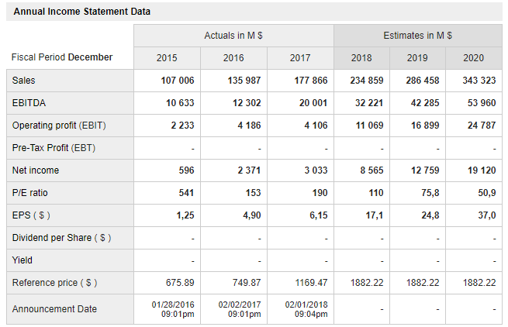
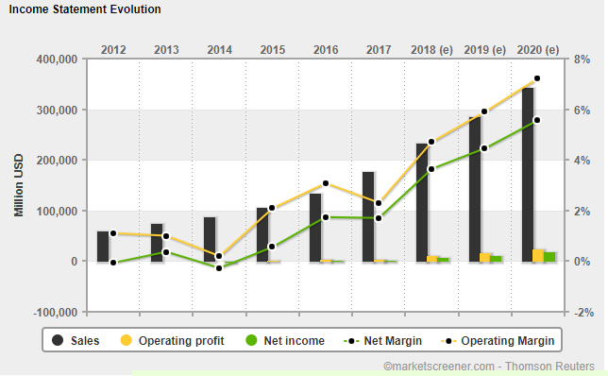
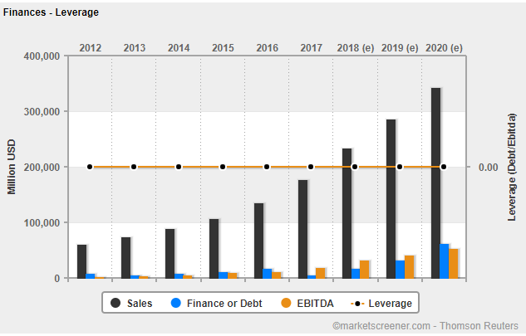
- Balance Sheet
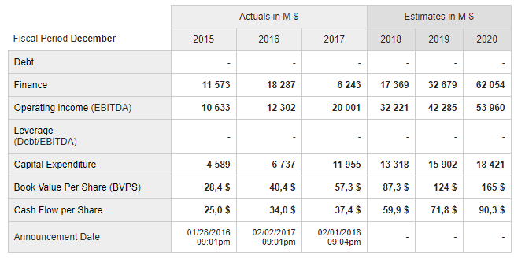
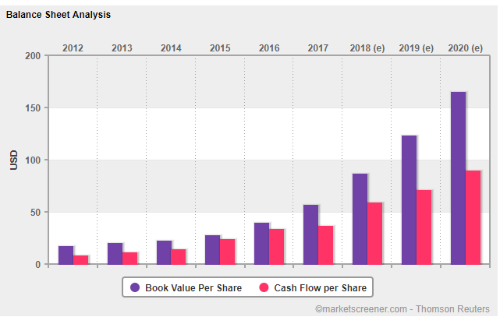
Amazon’s Ratio Analysis
- Profitability
In measuring Amazon’s overall performance, one should apply a methodical approach that begins with calculating the return on equity (ROE) (Financial analysis, 2016). Also, profitability is mainly broken under calculations that involve several financial measures. However, there are two profitability calculations that are used in this financial analysis- return on equity (ROE), and return on assets (ROA).
- Return on Equity (ROE)
ROE determines the generated profits by the company from the invested funds by the shareholders. As a result, the ROE is mainly a percentage and it is an advantage to track it year after year. Therefore, sound analysts and investors prefer an ROE that is positive (Financial analysis, 2016). For example, 3% or less ROE before being disaggregated will show that there is a serious financial downturn, a loss of stock valuation and investor confidence. Amazon’s ROE in 2017 can be calculated as shown below:
ROE = Net Income / Shareholder’s Equity
Net income = 3,033,000,000
Shareholder’s Equity = 23,493,000,000
ROE = 3,033,000,000/493,000,000 = 0.1291 ×100%
ROE = 12.91%
Given the ROE calculations above, it shows that Amazon was able to use the invested funds by the shareholders to generate a return of 12.91% in 2017. For comparison sake, the average ROE in the US has remained to be almost 10% during the entire 1990’s as well as early 2000’s. When compared to the historical data, Amazon reported returns that were above average in 2017. Such returns reflect the company’s supernormal sales growth that can be determined through diversification of revenue, economies of scale, reinvesting profit, and growth of assets. Nevertheless, the firm’s cost of capital could have affecting its ROE.
- Return on Assets (ROA)
Also known as the return on investment (ROI), the return on assets (ROA) is a measure of how the management of the firm uses the assets in generating earnings (Financial analysis, 2016). With the ROA, sound investors can determine how much the firm’s assets generate positive earnings such as profits. Like the ROE, the ROA is also expressed as a percentage and is recommended that its calculations to be disaggregated and monitored year to year. However, very few managers remain to be efficacious through delivering high returns on assets/investment given little assets. Therefore, Amazon’s ROA in 2017 can be given as:
ROA = (Net income + (1-T) × Interest expense + MI in earning) / Average total assets
= {3,033,000 + (1-20.20%) × 549,000,000 + 0}/131,310,000
= (3,033,000 + 438,102,000)/ 131,310,000
= 3,471,102/131,310,000 = 0.0264
=2.64%
Compared to the historical data, the firm’s ROA was below zero in the year 2014. However, the company has been making constant investments to report a positive ROA of 2.64% in 2017. Given the financial statements, Amazon seems to be targeting a positive ROA for the next three years.
- Liquidity
A firm’s liquidity is its potential to achieve its short-term financial objectives. Also. Liquidity ratios aim at examining the rate at which a firm can pay off the short-term debts by comparing its liquid assets with its short-term liabilities (Subramanyam, 2014). Therefore, the greater the coverage level of the liquid assets to the short-term debt, the better. If a company has a low rate of coverage, it is a sign that it may encounter difficulties in fulfilling its short-term objectives, and consequently in its daily operations. The table below shows three liquidity ratios used to determine Amazon’s ability to meet its short-term objectives:
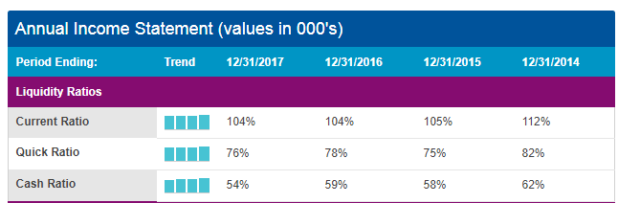
a. Current ratio
Current ratio shows how Amazon is able to cover or fulfil its short-term liabilities using its current assets. Therefore, the current ratio is given by:
Current ratio = current assets/ current liabilities.
In 2017, Amazon reported current assets of $60,197,000 and current liabilities of $57,883,000. Therefore, the company’s current ratio was given by 60,197,000/57,883,000 = 1.04 times as indicated in the table above. This shows that Amazon is well-situated to meet its current short-term debts since it has a current ratio that is greater than 1.0.
- Quick ratio
Also referred as the acid-test ratio, the quick ratio serves as a liquidity ratio that modifies the current ratio further through determining the level of the available current assets that are most liquidated in covering the current liabilities (Subramanyam, 2014). Besides, the quick ratio appears to be highly conservative compared to the current ratio since it does not include inventory as well as the other current assets, that are generally more challenging in turning them into cash. Therefore, a higher quick ratio implies that the company is in a more liquid current situation. The formula for calculating quick ratio is shown below:
Quick ratio = (Cash equivalents + marketable securities + accounts receivables)/ current liabilities
= (20,522,000 + 45,050,760 + 13,164,000)/103,601,000
= 7.6%
By considering the current assets that generally appear easy to be converted into cash, the quick ratio remains a conceivably better barometer of the provide coverage by such assets for the firm’s current liability if the business experiences financial constraints. Moreover, the inventory is viewed as less liquid compared to such assets. Therefore, a rule of thumb remains that with a quick ratio that is more than 1.0, Amazon is perhaps capable of meeting its short-term debts.
Economic Value Added (EVA)
EVA measures the financial performance of a firm based on the calculated residual wealth through its cost of capital deduction from the operating profits, after being adjusted for taxes on a cash perspective. Also, EVA is known as the economic profit of a firm, since it aims at capturing the real economic profit for the company (Subramanyam, 2014). Specifically, EVA is used in measuring the value generated by a company from the invested funds. Therefore, if the EVA turns out to be negative, it implies that the firm is not producing value from the in invested funds. Conversely, the EVA is positive, it implies that the firm produces value from the invested funds. However, EVA is calculated using the following formula:
Net Operating Profit After Taxes (NOPAT)- Invested Capital × Weighted Average Cost of Capital (WACC).
The above equation implies that EVA has three elements. The primary goal of EVA is determining the cost or charge of investing capital into a specific project and assessing if the investment yields sufficient funds to be taken as a good investment. The charge, however, reflects the minimum return required by investors in making the investment to be worthy of their capital. If the EVA is positive, it shows that a project is producing profits in excess of the minimum return required. Given such detailed explanation, Amazon’s EVA is given below:
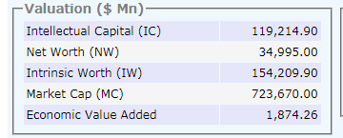
Synopsis of the findings
Amazon.com remains to be among the most valued, mega-cap firms in the world. The firm possesses a high premium value since it demonstrates a record of continued growth of sales. Nevertheless, Amazon perhaps could turn up grossly undervalued when analyzed using the earning-based and normal valuation measures (Subramanyam, 2014). Therefore, various valuation approaches need to be closely examined to appropriately gauge the difference between Amazon’s market valuation and business aspects. In Amazon’s business, the firm sets very competitive prices when selling everything; hence leaving little space for the profit levels.
- Sales Growth Rate
Throughout the corporate history, Amazon has reported continuous growth with a five-year sales growth rate that is almost 30%. However, Amazon is still making a lot a capital investments year by year, through mainly using the operations’ cash flow facilitated by a moderate debt amount and leaving very little cash since all eyes are focused on growth. Apart from leading an e-commerce retailing, the company also operates a publishing platform for publishers and authors whereby it takes a share of the sales from each book its sales (Subramanyam, 2014). Initially beginning as an online bookseller company, Amazon still keeps and augments its traditional book busiest that still facilitate its sales growth as of November 2017.
Amazon Web Services (AWS) appears to be a lesser-known business of the company to some. The AWS is a built internet cloud infrastructure belonging to Amazon but it is also rented to the other enterprises and developers so that they can operate their online activities. By taking an advantage of its expertise and experience of Web operation, the company established the AWS earlier compared to its competitors such as Microsoft’s Azure. However, AWS is perhaps Amazon’s fast-growing revenue source that has reported a sales growth rate of almost 40% over the last three years. Notwithstanding, through a continuous cloud computing transition, AWS remains in for a strong growth period in the foreseeable future.
- Profit Margins
Amazon focuses on the top-line revenue, unlike most of its competitors that are more focused on their bottom-line profits and earnings. Amazon believes that by increasing its market share, its economies of scale can be leveraged in lowering cost and also exercise some pricing power over the consumers who highly depend on the company. However, these earning-flowing periods need to arrive as soon as possible rather than being late for Amazon. Failure to make sufficient funds to eventually grow the initial investments from the shareholders, Amazon may experience challenges in sustaining its sales exuberance over the long run. For the period ending November 2017, the firm’s net profit margin and operating margin happened to be 0.35% and 1.71% respectively. Also, Amazon even lost funds in various quarters. These anaemic profitability performance does not facilitate much to the shareholders’ equity increase as well as the actual book value of the company, exposing its stock to a potential volatility of price.
- Valuation Measures
In the market, Amazon’s stock has been solely valued based on its growth potential. Therefore, numbers had been valued based on the traditional valuation frameworks like the price-to-book (P/B) and price-to-earnings (P/E) ratios. Such ratios consider Amazon’s stratosphere. Amazon’s P/B and P/E ratios remain to be over 30 and 900 respectively, indicating a genuine feat that is not present even to the other companies that are more valuable (Subramanyam, 2014). Generally, fairly value firms mainly have P/B ratios that are in the low single digits and P/E ratios that are in the mid-teens. However, Amazon needs to start expanding its equity base and increase its earnings in order to control its high-flying valuation figures. Nevertheless, such a strategy needs changes in the business strategies like shifting the operations gradually from the sales-centric to the earnings-focused. Such a step will perhaps shift most of the earnings growth in levelling out the current valuation of stock if the investors appear to be attracted with the stories concerning future earnings.
Major Financial Risks from Operating Internationally
All the public traded companies in the United States are obliged to file annual reports on their financial outcomes. Such requirements are made by the Securities & Exchange Commission. In the reports, there is a segment that advises the potential and existing investors to the associated risk factors with investing in the companies (Melnikov, 2011). Such risk factors depend on the view of the executive management concerning the potential risks as well as the unpredictable activities that may surface in the long run, causing an adverse effect on the company’s material. Therefore, the following are Amazon’s associate financial risks from its international operations:
- Amazon experience intense competition
- The company’s expansion poses a critical strain on its management, financial, operational, and the other resources
- The company’s expansion into new services, products, geographic areas, and technologies exposes the company to the additional legal, business, competitive, and financial risks.
- Amazon may face notable fluctuations in its operating outcomes and rate of growth.

References
Datamonitor (Firm). (2000). Amazon.com, Inc. New York, NY: Datamonitor.
Financial analysis. (2016).
https://www.nasdaq.com/symbol/amzn/financials?query=balance-sheet
Jorion, P., & Global Association of Risk Professionals. (2007). Financial risk manager handbook. Hoboken, N.J: John Wiley & Sons, Inc.
Melnikov, A. (2011). Risk analysis in finance and insurance. Boca Raton: CRC Press.
Subramanyam, K. R. (2014). Financial statement analysis.

